SWADHIKAR
Annual Report

2010-2011

Content

S.No | Particulars | Page No
I | Milestones in 2010-11
 | - Dalit Arthik Adhikar Andolan | 3-12
 | - All India Dalit Mahila Adhikar Manch | 12-17
 | - National Dalit Movement for Justice | 17-25
 | - International Advocacy & SWADHIKAR Coalition | 26-29
II | Our Strength - Our team | 30-31

DALIT ARTHIK ADHIKAR MANCH (DAAA)

Review & Discussion on SCP & TSP Study, February 2-3
A workshop was organized on the “Priority for Scheduled Castes and Scheduled Tribes in the Union and State Budgets”, jointly with CBGA at SWADHIKAR Office, New Delhi. The purpose was to review and deliberate on the study conducted on SCP & TSP in the Union budget, in 08 states, namely Andhra Pradesh, Bihar, Delhi, Gujarat, Madhya Pradesh, Orissa, Rajasthan and Uttar Pradesh. The final draft was made for the study for each States Budget and Union Budget in the workshop.

National Seminar on SCP, February 6, Patna, Bihar
A National Seminar on the SCP was conducted jointly by Vanchit Prathisthan and DAAA-SWADHIKAR. The occasion had among its distinguished members, the Governor, Shri. Devanand Konwar, Mr. Harkishore Singh, the Deputy Chairman of the Bihar Planning Board Commission, and Mr. Sanjay Paswan, the Former Union Minister. The members of the civil society, academicians, youth and students from the state also joined for the meeting. The share of SCs in the SCP in the national and Bihar state context were presented.

This one day programme aimed to bring together the CSOs and likeminded people and groups to launch a campaign in the state, to educate Dalits on their rights and entitlements. The efforts were also made to influence the union budget of 2011-12 and 2012-13.

Rally in Rajasthan, February 18
A rally was organised for the Implementation of SCP, by the networks from across Rajasthan in Jaipur, including DAAA. Hundreds of people from different organization attended the Rally and submitted Demands for the Dalits to Chief Minister for 2011-12 state budget.

State level Consultation on SCP with MLAs, February 20, Bhubaneswar, Orissa
The research and findings of SCP and TSP budget tracking done by DAAA and CYSD were shared with the MLAs. The key challenges before the SCP & TSP were highlighted in conjunction with key recommendations. Subsequently, there was planning and discussion among the MLAs, where they voiced out their respective problems and how the budget is being implemented for the SCs & STs. The Former Finance Minister of state, Mr. Panchanana Kanungo, stated the need for such continuous engagements with the MLAs on the subject. There were also discussions on raising SCP and TSP related critical questions in the assembly session by the MLAs for the just allocation and implementation of the SCP and TSP. The consultation was held with support from the UNDP, CYSD, CBGA, & OMASA.

Pre-budget consultation with the Chief Minister of Rajasthan
DAAA participated in the Pre-budget Consultation with the Chief Minister of Rajasthan and Ministers and Secretaries from all the departments. It presented the case on SCP and the concerns articulated were admitted by the Chief Minister of state, with an assurance that the state budget for 2011-2012 would endorse all demands raised. Demands raised were- opening of SCP minor code 789 in all departments for enabling clear allocations and making the funds trackable; allocations according to population percentage; appointment of Nodal Officers; and improvement in Hostel for SCs students.

Consultation with the MLAs, February 21, Jaipur, Rajasthan
A consultation with the Members of Legislative Assembly (MLAs) was organised by the DAAA team of Jaipur, together with BARC. Fruitful discussions took place with 12 MLAs on the Sambhal Gram Yojana on SCP.

Analysis of SCP & TSP Budget 2011-12
After the Rajasthan Govt. presented the Budget on 09 March in the Vidhan Sabha, DAAA team in Rajasthan immediately analyzed the SCP and TSP allocation in 2011-12 state budgets. Due to our continuous advocacy and lobby with the Rajasthan govt., this year the govt. of Rajasthan has allocate 11% for SCP and 8% for TSP of the Total State Plan Budget, which is more than the allocation made for SC/ STs in comparison to previous years.

Press Conference and Consultation with the MLAs, February 21, Lucknow, Uttar Pradesh
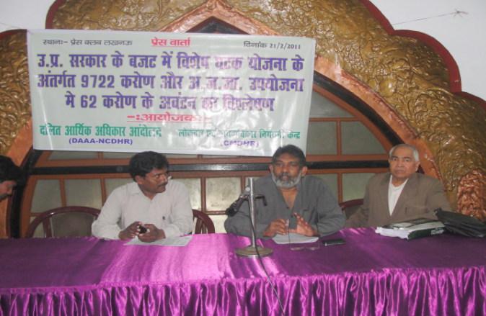

A press conference and a state level consultation on the Status of the Special Component Plan was organized in partnership with Dalit organizations in UP. A state Planning Commission Director were present in the consultation, besides approx. 40 NGOs being a part of it. A state level SCP Andolan (campaign) was resolved to be initiated.

Press Release on SCP & TSP of Union Budget 2011-12, February 28
SWADHIKAR did an initial analysis of the allocations announced and funds earmarked for SCP and TSP in the union budget 2011-12, which was placed in the Parliament on Feb 28. This was done for an advance release to the print and electronic media. As reported by the media, in this union budget, fund allocations for SCs and STs were to be put under separate head of accounts (Minor head 789 and 796) for the first time. The FM also had said that the government may be allocating in the range of Rs. Cr. 45,000-50,000.However, the analysis revealed that the UPA has denied SCs Rs.Cr. 24,570 in SCSP and STs Rs. Cr. 10530 in TSP.

State level follow up consultation with MLAs on SCP & TSP, 23 March, Red Cross Bhawan, Orissa
A state level consultation was organized with 15 MLAs on the SCP & TSP with the objective of raising the SCP & TSP issues in the forthcoming SC/ST Budget discussion, scheduled for 25 March 2011, in the Orissa Assembly. Through this consultation the aim was to sensitize the MLAs on the issues pertaining to the Special Component Plan and Tribal Sub-Plan policy and its status in Orissa.

Analysis of the Delhi Budget for the year 2011-12
Bihar Success Story and Analysis of 2011-12

Bihar Government has opened the vehemently demanded minor code 789 for the SCP in the budget for 2011-12, presented on February 25. DAAA-SWADHIKAR had been advocating for it for the last 3 years. Several rounds of meetings were held in 2010 and last in January 2011, with the Minister of Social Welfare and the Joint Secretary before the budget session. Out of 62 Departments, 25 have made allocations, which marks an increase of over 20 departments compared to the previous year.
Delhi state budget for the year 2011-12 was presented on 25 March, and analyzed by DAAA team. As per the analysis, it is found that this year the Delhi Govt. has allocated only 2.61% of the total State Plan Budget for the SCs, which is very less in comparison to their population in the state. Advocacy and lobby agenda will now revolve round these findings to make the governments allocate in proportion to the population of SCs.

Study on SCSP & TSP for UNDP, 2011
This year, DAAA and CBGA jointly commissioned a study, supported by UNDP, on SCSP and TSP. We examine the implementation of SCSP and TSP fund earmarked for SC and STs and the amount placed under separate budget heads/sub-heads for each ministry/department for implementing the schemes and programmes.

As it’s known that the Special Component Plan and Tribal Sub Plan was started in 1979-80 for the targeted benefit of SCs and STs to bring them at par with general community. But many government reports reveal the fact that SCP and TSP has not been implemented in true sense and the opportunity to develop these communities has been missed.

In order to bring them out, know the existing situation and gaps in the policy this joint study on Implementation of Special Component Plan and Tribal Sub Plan at Union and in 5 states sponsored by UNDP has been conducted.

National Level Consultation on SCP and TSP Implementation at Union and State Levels, New Delhi, August 26, New Delhi
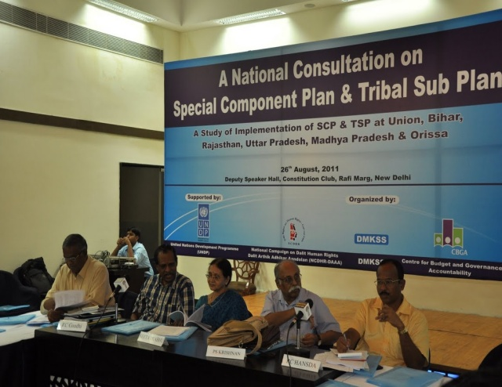
National Level Consultation was organised on Implementation of Special Component Plan and Tribal Sub-Plan at the Union and State Levels, at Constitutional Club, New Delhi, by SWADHIKAR and Centre for Budget Governance and Accountability (CBGA) support by UNDP. Study report conducted by SWADHIKAR and CBJA on the status of implementation of SCP and TSP at Union and states like Bihar, Rajasthan, Uttar Pradesh, Madhya Pradesh and Orissa was presented.
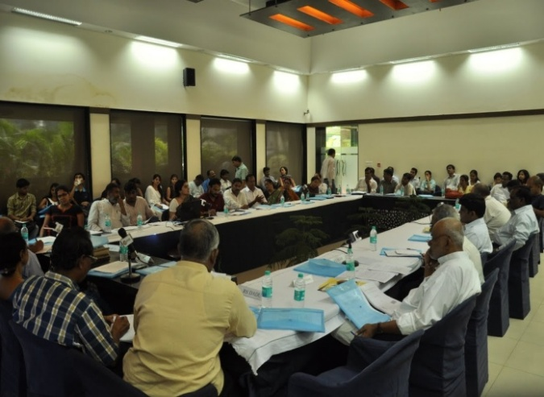
The study revealed that:
- Even though states have started allocating SCP and TSP fund according to the guidelines, the nature of allocation is dubious and violates principle of SCP and TSP.
- Most of the allocations are notional and are not directed to the people.
- The study shows that institutional mechanisms and monitoring mechanisms are lacking in all states and at union level.

MAPPING OF SC SETTLEMENTS IN DELHI

The SCP funds are either diverted or misused when it comes to implementation. This is what happened even in the Grand ‘Common’ Wealth Games (CWG), in which the Government of Delhi affirmed that Rs. 744.354 crore from the SCP fund were utilized for the Commonwealth Games, 2010. In order to bridge the divide between real needs of the people and policies of the government, DAAA with some partners has embarked on assessing the need of the SC community. The exercise of mapping SC settlements in the Delhi started in January 2011, wherein, 15 SC settlements were identified. This initiative is expected to evolve Community Plans based on their needs and generate demands through community participation and hence, would be recommended under the SCP funds that are to be brought back by the Delhi government. It will create awareness among the communities in these colonies and capacitate them in utilizing the resources available under the SCSP for their economic and educational development.
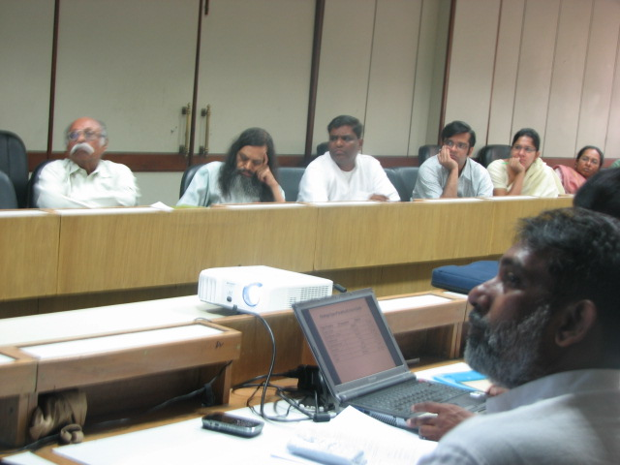
Expert Group meeting on the draft report of mapping & the study on the scheduled castes in Delhi, April 25, YMCA, Delhi

An Expert Group meeting was held to discuss and reflect upon the draft report of the study on the Scheduled Castes in Delhi, their current status and access to entitlements by National Campaign on Dalit Human Rights (SWADHIKAR) in consultation with Civil Society Organizations and networks involved in raising Delhi urban concerns. The main objective was to discuss and suggest a way forward so that the long due entitlements for the SC communities in Delhi get realized.

Follow up to the suggestions given by Expert Group Meeting for Delhi Mapping
Following the suggestions from Expert Group meeting held at YMCA last month and to enrich the ongoing study, which is planned to be published in the form of a mapping report consisting of the findings from a comparative survey- in all possible areas, including entitlements, education, employment, entrepreneurship, health, and housing, while focusing on the situation of SCs in Delhi, a team of SWADHIKAR workers and interns visited selected bastis to collect required qualitative information/data between May 21 and 31 . The team visited selected pockets in areas, namely, Bhalswa (on May 21 and 23 ), Jahangirpuri (on 25 May), Tigri (on May 27-28) and Baljeet Nagar (on May 30-31). For collecting information, the team members relied on discussions in informal ways as far as their interaction with the community was concerned. Also, Focused Group Discussions and the capacity of observation were used to the fullest in the process.

FIGHT AGAINST UNLAWFUL DEMOLITIONS

On the 23rd of March the Delhi Development Authority (DDA) bulldozed 750 houses in the Gayatri colony, New Delhi- 80% of which belong to Dalits-DAAA intervention
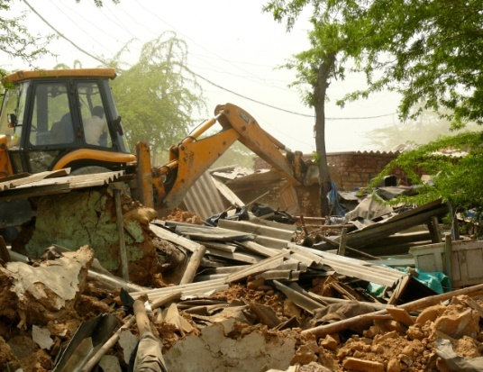
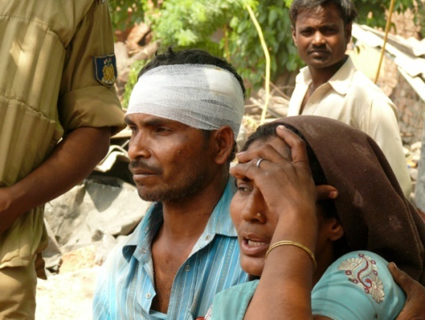

A large scale demolition was carried out on March 23-24, 2011, by the Delhi Development Authority (DDA) affecting over 4,000 residents of Baljeet Nagar/ Gayatri Colony at West Patel Nagar, New Delhi. The action was stayed after legal intervention by the Delhi High Court after the joint intervention of DAAA-SWADHIKAR, Human Rights Law Network, Indo Global Social Service Society, Housing and Land Rights Network, LEDS, Centre for Social Equity and Inclusion and Sahari Adhikar Manch. Despite several High Court orders mandating for immediate provision of basic facilities, such as water, food and sanitation in case of a demolition, residents of Baljeet Nagar were deprived of their fundamental rights.

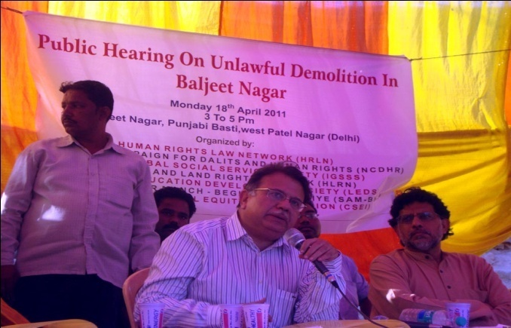
Public Hearing on Unlawful Demolition in Baljeet Nagar, New Delhi on April 18, 2011

Taking these violations into consideration these organisations jointly organized a public hearing at the basti. Among the distinguished persons of the jury were Justice AP Shah, former Chief Justice, Delhi High Court and Chair of the Jury, Mr. Miloon Kothari. Testimonies highlighting the effects of demolition on the residents, like students having to forego their examination, detailed accounts of elderly, working men and women, pregnant and lactating women were presented before the jury members. A case of five years old, Anish, who lost his eye sight during the demolition, was presented before the jury.
Another unruly demolition designed by MCD of Dalit habitants, Karol Bagh, New Delhi
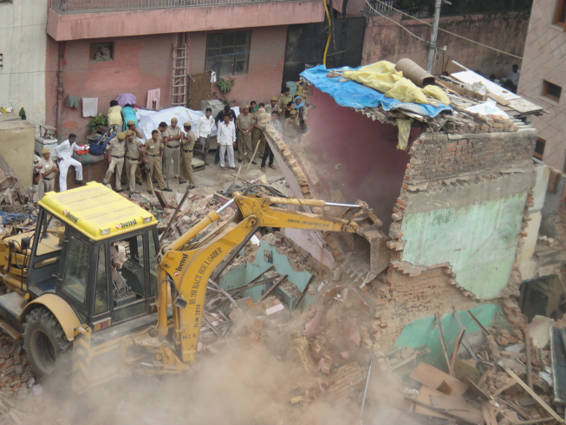
DAAA intervened in yet another case of unlawful eviction of Dalit families in New Delhi.
On Thursday, 28 July 2011, the Municipal Corporation of Delhi (MCD) demolished the houses of 15 Dalit families who had been living in the Karol Bagh area for the past 60 years. The demolition was conducted without any due process in clear violation of the residents’ constitutional and statutory rights. The forced eviction occurred even though an urgent petition had been filed on behalf of the residents by the Human Rights Law Network (HRLN) in the Delhi High Court, challenging the legality of the eviction.

These families having population of 80 people, who have been residing in the area, a very posh locality, for decades, possessing ration cards, voter I-cards, birth certificate, death certificates, electricity bills and water bills etc. on the given residence address. The residents were all taken by utter shock. The families reported that they had maximum 30 minutes to salvage their belongings, due to which very little could be saved and the rest is now forming part of debris.

The people from the dominant castes in the locality called them by caste names and mistreated them. They could not stomach the sight of Dalits living next to them. The Resident Welfare Association of the area used RTI as their tool to obtain information about the legal tenure of these Dalit families, resulting in the eviction of these families.

A petition is filed at the Delhi High Court and the various partnering organisations have started thinking of alternate ways of holding the government authorities responsible for the miscarriage of the norms and violation of human rights. It’s hard to see how in urban settings also casteism is exercising its strong hold over the educated masses.

DAAA-NATIONAL DALIT WATCH

In order to chalk out specific strategies to demand the entitlements of the Yamuna flood affected people in 2010, a preliminary meeting of all concerned organizations and individuals was arranged by NDW, on January7, 2011, at SWADHIKAR office.

Prior to this, a survey was conducted to ascertain the extent of inclusion / exclusion of Dalits in relief and rehabilitation measures during the Yamuna floods of 2010. The survey was undertaken in the areas of Vijay Ghat, Shastri Park and Mayur Vihar phase I & II, from October 19-25, 2010. The findings revealed that despite most victims of the flood turned out to be Dalits and other marginalised sections. Despite the major loss of crops and other belonging, the Delhi government has not yet announced any compensation to the agricultural labourers cultivating the river bed for years on lease basis. Moreover, no damage assessment has been carried out by the government post flood, which has led to the exclusion of victims from their rightful compensation. With this meeting, the process from gathering of representation/applications from the victims to their submission and meeting with the authorities was mutually decided upon.

Community consultation with the community surveyed at Shastri Park, on Jan 29, to inform them of further planned actions, following the above meeting. IGSSS representatives attended the meeting.

In Karnataka, NDW works collaboratively with the Human Rights Forum for Dalit Liberation-Karnataka on disaster risk reduction. On January 8, 2011, HRFDL-K organised a state committee meeting to discuss the activities and strategies for the long pending rehabilitation of (2009) flood victims. It has been decided to carry out the programme in three worst affected districts of Bijapur, Raichur and Bellary (Sirgoppa), covering specifically two Panchayat areas.

Workshop on Vulnerability Mapping and Inclusion monitoring in the context of disasters, from a Dalit Perspective, 10-11 March, in SWADHIKAR, New Delhi
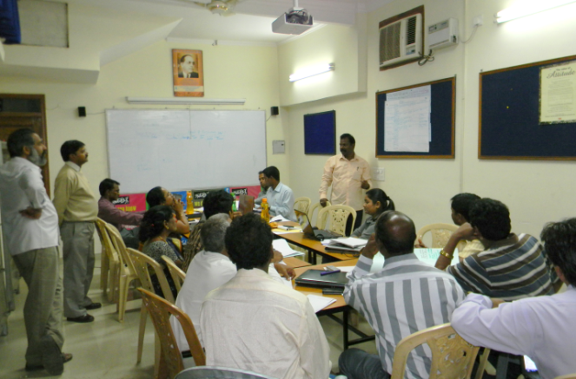
The objectives of the workshop were (i) to develop a clear conceptual and practical understanding of exclusion of Dalit communities in disasters and learn methods to monitor and record such practices of exclusion; and (ii) to equip the state / organizational representatives to train their frontline staff in inclusion monitoring during and after disasters.

While NDW would capacitate task forces, a cadre of 25-30 volunteers in the states of Andhra Pradesh, Karnataka and Assam, initially, where it is currently operating, it also expects other humanitarian agencies working on DRR to work on such a model and replicate the same in their field of operation.

Joining hands with Sphere India on World Bank sponsored Bihar Kosi Flood Recovery Project

For reconstruction and rehabilitation, the Government of Bihar had announced “Bihar Kosi Flood Recovery Project” with the total cost of $259 million, out of which the World Bank had approved and granted $220 million (Rs. 1,000 Crores) as soft interest free loan. Sphere India has taken the initiative of identifying and addressing specific issues and gaps in the plan as well as large scale implementation of Kosi Rehabilitation project. For this, Dalit Watch Bihar and NDW have also joined the in the planning process, wherein a pilot survey of worst affected districts has been planned on sample basis. NDW and DW-BH intend to assess the inclusion aspect in the implementation of the project.

Participation in DDMP District level Stakeholders’ Consultation’ at Madhubani, Bihar, 9-11 June 2011

NDW representative participated in the ‘DDMP District level Stakeholders’ Consultation’ at Madhubani, Bihar, organized by Sphere India. NDW participation was called upon to for highlighting the aspect of inclusion of Dalits and other marginalized groups in the process of formulation of District Disaster Management Plans, to the government officials and civil society organizations present in the consultation.

Compensation to the victims of Yamuna flood of 2010
The process of collecting application from the victims of the Yamuna flood of 2010, to be submitted to the concerned government authorities was initiated and completed in two locations of the three surveyed ones, namely, Mayur Vihar and Shastri Park. The process is on in Vijay Ghat now.

RTI to seek information on the compensation secured by 1135 Dalit families, on the basis of list submitted by DW-AP after 2009 floods
RTI has been filed to the Commissioner, Disaster Management of State Disaster Management Department, seeking progress made or action taken on representations submitted after flood, list of such families with the exact details of the compensation given, and reasons why these families did not receive compensation earlier. Responses are awaited.

Capacity building of DBSU members (active part of DW-AP working network), July 22, 2011, Mehboobnagar district, AP
DW-AP held a meeting in Mehboobnagar district which was attended by the members and leaders of Dalit Bahujan Shramik Union (DBSU) from 100 mandals from across 8 blocks of the district. Information on disaster management and Calamity Relief Fund scheme was disseminated among the participants, both with respect to floods and droughts.

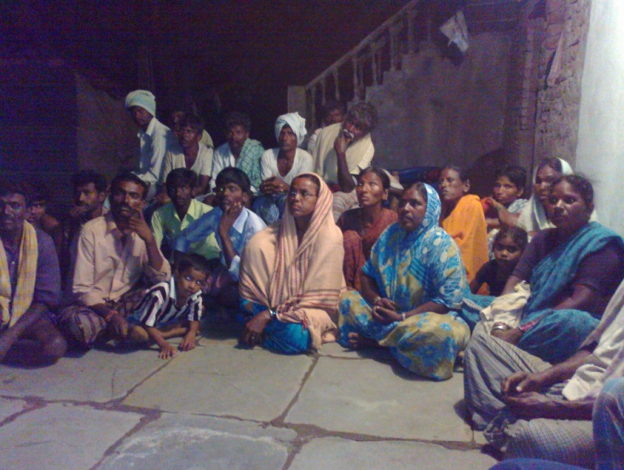
District level consultation, Mehboobnagar district, Andhra Pradesh, August 29

About 20 organisations besides peoples’ movements representatives gathered on the occasion, and resolved to take forward the issues taken up by DW-AP and also make visits to the villages surveyed by DW-AP during the 2009 floods and further talk to the excluded beneficiaries, to find out how many received compensation after the submission of representations to the authorities. It was also resolved to hold block level programmes with the excluded survivors, after the completion of this revisiting process by NGOs. The representatives also met with the Collector enquiring about representation made till now.

Vulnerability Mapping and Inclusion Monitoring exercise in Andhra Pradesh
After the successful completion of the VM-IM workshop for the volunteers in the first week of July, the actual pilot application of the VM-IM tool started in the identified village/s of districts of Mehboob Nagar, Kurnool, Vijaynagaram and Prakasham in August. Issues and awareness which came up with just the pilot application have resulted in public action in different districts spilling across the month.

“VM-IM” exercises at village levels, Assam, by Rural Volunteers Centre-NDW
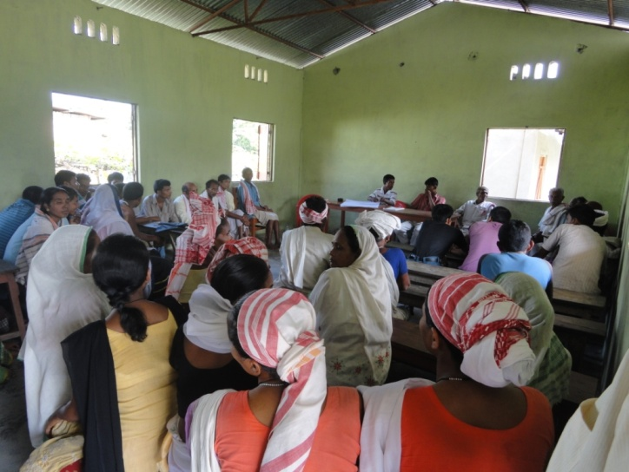
“VM-IM” exercises are being conducted by the trained volunteers in the villages, namely, Bhuramora in Jorhat District and Puthimarhi in Lakhimpur district, respectively, scheduled to be concluded by October 10. Some of the initial findings of these exercises have revealed that (i) the awareness camps conducted by the Government in the pre-flood period are restricted to the road side areas thus the riverine SC community of the villages fails to participate;(ii) people of these villages reflected that social security schemes like PDS, ICDS, NRHM etc. have become non-functional; (iii) they have to bribe the Govt. officials to avail the benefits under various Govt. schemes; (iii) they are often left out from the evacuation plan of the Government and ultimately from evacuation; & (iv) Government’s assessment process to list the flood affected villages often exclude the Puthimarhi village. Actions are to be further built on these findings for building back better in real sense of the term.
Sit-in in Kollapur district, Andhra Pradesh, August 22, 2011

45 SC/ST families from Molachintalapalli village, submitted representation to the Revenue officer on the issue of non realization of the allotment of land, done by the SC Corporation few years back, on paper. The local panchayat is yet to give possession of land to these families which were affected by 2009 floods. This issue surfaced during the VM-IM pilot exercise with the villagers. A mass action was organized on August 26, in Allampur block of M’nagar district. The non-compensated victims demanded proper housing entitlements for themselves since some were still living in temporary sheds provided at the time of 2009 floods. In the monsoon of 2010, these families suffered damage to their existing houses. About 200 SC/ST/BC families are suffering for want of housing entitlement from the government. They continue to live in the fear of impending monsoonal uproar. Representations have been submitted individually by the victims facilitated by DW-AP.

All India Dalit Mahila Manch (AIDMAM)

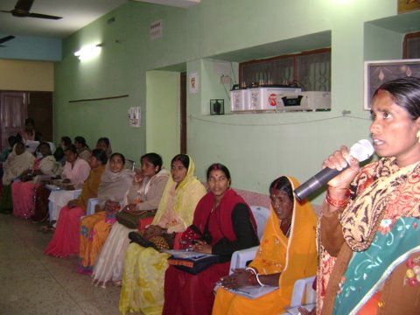
AIDMAM organised a State level workshop on ‘Dalit Women Elected Representatives at Local Governance and their role in Criminal Justice system’ , in Patna, Bihar,on January 28, 2011.

The workshop was inaugurated by Ex-Chief Minister and Ex-Union Minister, Shri Jagannath Mishra. The workshop addressed the issue of untouchability and violence (including domestic violence) on Dalit Women and discrimination at all levels including schools, ICDS, NREGA, Land, Budget and in accessing civic amenities. The participants were informed on how to access legal and administrative systems to address violence against Dalit Women to secure justice for them. Information was disseminated on Domestic Violence Act, 2005 and the SCs &STs (PoA) Act, 1989. The workshop witnessed participation of Dalit Women Elected Representatives (DWERs) from 14 districts of Bihar. AIDMAM was able to generate visibility of their work among Govt. officers and also civil society members. It also brought together women and support groups from many more districts with the hope of strengthening the role of Dalit women in panchayats

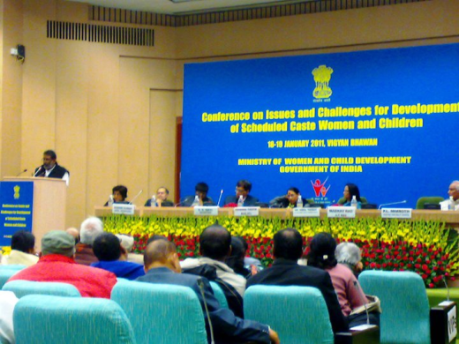
On January 18-19, 2011, AIDMAM participated and shared about the plight of Dalit women in the country, at the Conference on, ‘Issues & Challenges for Development of Scheduled Caste Women & Children’, organized by the Ministry of Women & Child Development, at Vigyan Bhavan, in New Delhi.

AIDMAM’s solidarity in Women in Governance network (WinG)

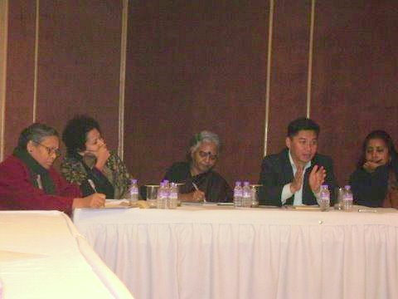
On January 29, 2011, AIDMAM facilitated a panel discussion held by WinG on United Nations Security Council Resolution 1325, WinG is a unique network of women who are striving to be change agents in a world dominated by patriarchal and casteist traditions. The members of WinG are all women from marginalized communities who are working for women’s rights and trying to assist in creating space for women to become leaders in their communities. The conference brought together Dalit women and women from North East states to share and brainstorm over common issues and devise a clear strategy to build capacities of women towards leadership, both is civil society as well as governance. Concept of Human Security was further analyzed from the perspective of women. Situations and contexts of human rights defenders were further probed to understand the unique challenges of women human rights defenders.

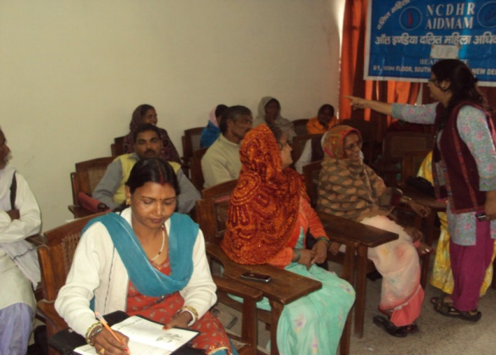
Capacitation programme for Dalit women elected representative (DWER), February 16-17, Uttar Pradesh
As a part of AIDMAM’s ongoing initiative on Access to justice, a two day training programme was organized in Uttar Pradesh. The meeting witnessed participation of DWERs and Dalit women activists from three district of UP and two districts of Bihar. The participants comprised a fresh batch of DWER from UP. The participants were given detailed inputs on Domestic Violence Act, 2005 and SCs & STs (Prevention of Atrocities) Act, familiarizing them with the concept of gender and the dynamics of patriarchy. The training also threw light on Sexual harassment at workplace, the different forms of harassment, and the importance of constitution of a Sexual harassment committee. The training was facilitated by a resource person from Jagori.

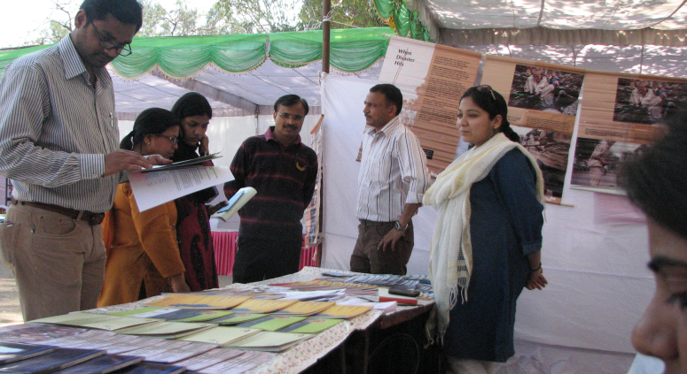
AIDMAM initiated a network of Civil society members to address the issue of violence against Dalit women in Panipat, Haryana, on February 10, with an aim to create a strong network of Dalits’ rights activists, Dalit advocates and community based organizations. The participants shared the Dalit rights situation in Haryana, dominance and role of caste panchayats and Dalit women situation in Haryana. All participants stressed on the need for a stronger solidarity network of individuals and organizations working towards equal and just society.The meeting concluded with the resolution to schedule more follow up meetings for further strengthening the network to protect Dalit women from all kinds of caste induced violence.

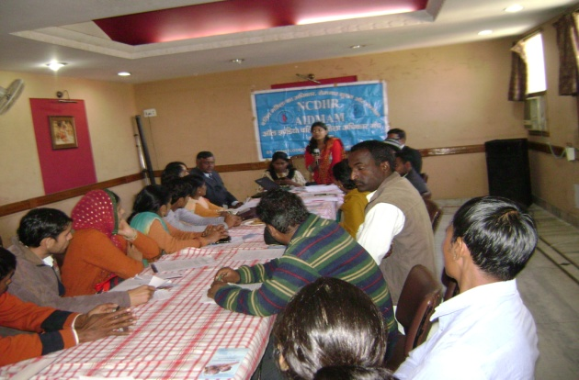
Dalit women network meeting in Lucknow, 30 March
A Dalit women network meeting was organized in Lucknow, wherein, 23 dalit women activists from ten districts participated. The district co-ordinators shared the situation of state, district and block level legal service authority, which are non functional and not delivering what is expected from them. All participants stressed on the need for a stronger solidarity network of Dalit women and need for capacitation programme on domestic violence and available legal aspects. The meeting concluded with the resolution to create strong state level dalit women elected representative network to address the concerns of Dalit women.

Prof. Vimal Thorat, the Convenor of AIDMAM, participated in the 3-day National Conference of Dalit Women of Nepal,
organised by Dalit Feminist Organisation (FEDO), at Kathmandu, from 11 -13 May. The conference witnessed attendance of Dalit women activists from 75 districts of Nepal ,Human Rights Activists, constitutional assembly members, representatives from the UN and bilateral agencies and NGOs, delegates from India, Bangladesh, Sweden, U.K, Hongkong and Denmark.
The supreme focus of the conference was the demand of inclusive policy and social transformation of the Dalit community. The Convenor spoke of the similarity of Caste discrimination and exclusion of the Dalit women in India and Nepal. The ‘badi’ system in Nepal is the same as Devdasi system in India besides other similar forms of exclusion and discrimination. Therefore, Dalit women put forcefully put forth the demand for equal distribution of the resources of the country.
Women’s day Rally in Jaunpur, Uttar Pradesh

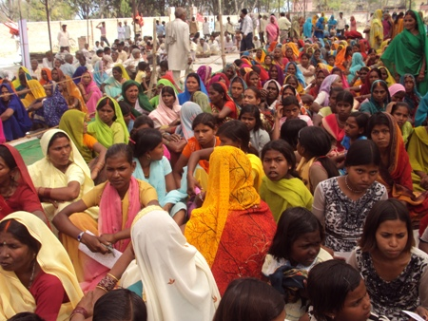
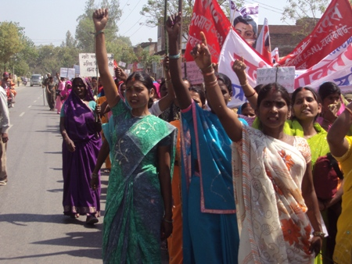

AIDMAM invited for a guest lecture by Amity University, Noida, UP, 01 March
AIDMAM was invited to deliver a guest lecture to the students of MBA programme in Rural Management. After the screening of a documentary which talks about caste practices in today’s India. The students were explained the marginalization and vulnerability Dalit women face when the dynamics of caste, gender and patriarchy find their manifestations in the form of violence and atrocities against them. Subsequently, the processes of exclusion of Dalits during and post disasters were explained

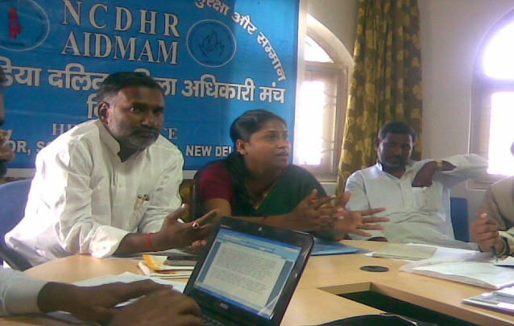
Round Table meeting & AIDMAM network meeting, 01 March, Aurangabad, Bihar
A round table meeting between district level officials, representative from UNDP, the DWERs and the Chairman of Scheduled Caste & Scheduled Tribe Commission, Dr. Yogendra Paswan, was organized in Aurangabad.The DWERs presented their concerns in front of the Chief Guest and the district officials present in the meeting. AIDMAM appraised the participants on the social, economic and political conditions of Dalit community with specific reference to Dalit women, and Dalit Women Elected Representative in Bihar.
Training on Gender and Caste based Violence for Dalit Panchayat members and activists, 28 - 29 June, Uttar Pradesh
Training on Gender and Caste based Violence for Dalit Panchayat members and activists in Jaunpur, Uttar Pradesh, on 28-29 June 2011, was held in collaboration with Bhartiya Jan Seva Ashram. About 35 Dalit women participated in the 2 day residential training, and shared their views on gender discrimination and also articulated their experiences of caste based violence faced in their daily lives. The training was held on violence against women and the laws, SC/ST (Prevention of Atrocities) Act and the role of Panchayat etc. During the 2-day training programme AIDMAM managed to reach out to the community and educate them about their rights to combat the discrimination they face every day.

A rally organized for free admission in Residential School and for higher Education of Dalit girls, 3 June, Bihar
On 3rd June in Aurangabad, Bihar, a rally was organized for free Admission in Residential School and for higher Education of Dalit girls by AIDMAM and Centre for Social Equity and Inclusion. There were about 250 children who took part in the rally. A memorandum was also drafted and submitted before the State SC/ST Welfare Minister and the State Education Minister.

Two day networking meeting of Dalit Women Activists on violence against Dalit women in Lucknow, July 30-31, 2011
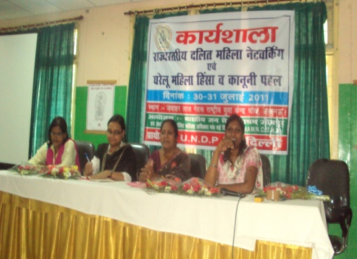
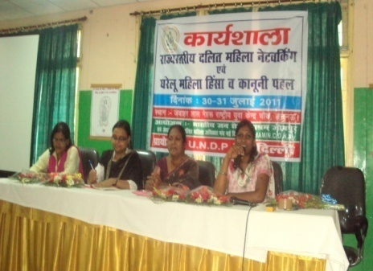
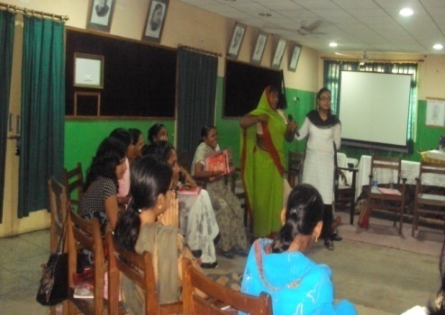
A 2 -day meeting was held in Lucknow for strengthening network of Dalit women activists in Lucknow. Ms. Asha Kowtal and Ambalika Roy along with entire team of AIDMAM helped in facilitating the entire meeting. The meeting was attended by 25 activists from several districts of UP. The main issue of deliberation was the multiple forms of victimization of Dalit women owing to their gender and caste.
The Secretary of the UP State legal services Authority, Ms. G Sreedevi inaugurated the meeting and also facilitated a session on free legal Aid and access to Justice System. She also enumerated the services available in the state of UP for availing legal aid. She briefed the group about the upcoming mobile van facility which would take complaints from all the villages of UP and help to redress such complain. A thorough discussion took place on understanding different dynamics of gender and patriarchy. A detailed discussion on the Protection of Domestic Violence Act and the Prevention of Atrocities on SC/ST Act was held as well. The meeting virtually led the foundation of a network of Dalit women activist in UP, which would be further strengthened in the upcoming meetings.

Fact finding at Barwani, Madhya Pradesh

AIDMAM has become a part of the National Alliance for Maternal Health and Human Rights (NAMHHR). As a part of the alliance, AIDMAM joined the team for fact finding in Barwani district in Madhya Pradesh on 26-27 August. Barwani, an area mostly inhabited by Dalits and Adivasis, and the district has suffered 22 maternal deaths in 8 months.

The fact finding team found that the hospitals have a shortage of sweepers, due to which, sometimes when the Dalit women who undergo delivery in the hospitals, their families are forced to be engaged in sweeping and swabbing the hospitals. AIDMAM intends to focus on the exclusion and discrimination of dalit women within the public health systems and the attitude of the doctors, nurses, sisters and compounders towards the socially excluded communities.

National Dalit Movement for Justice (NDMJ)

Survivors and Witnesses’ Deposition, February 15, Patna
The survivors and witnesses of 25 atrocity cases gathered in Patna, where more than 50 survivors and activists met under the presence of Scheduled Caste Commission Vice Chairperson, Mr. Jogender Paswan, State Human Rights Commission Chairperson, Mr. S. N. Jha and the State Cabinet Minister of Social Welfare, Mr. Jitan Ram Manjhi. The survivors presented their case, and the Social Welfare Minister while understanding the cases, gave assurance to monitor the case of burning alive the Dalits in Madhepura district and the gang rape case in Saharsa district.

Assessing Prisoners Rights and Discrimination Dalits face in Prison, February 17
A team comprising representatives of NDMJ visited ‘VARHAD’, and shared its strategies of intervening for the Prisoners Rights with the Founder president Mr. Ravindra Vaidyan. The team also identified various forms of caste discrimination in the prisons with a focus on Amravati Central Jail.

Survivors and Witnesses’ Meeting, February 17, Lucknow, Uttar Pradesh
The survivors and witnesses of 9 major atrocity cases assembled along with some Dalit Human Rights Defenders Mr. M. L. Arya (retired IAS), Ms. Rita Kaushik, (convener of Dalit Action Group) and Adv. Rekha Bharti from Mahila Adhikar Manch. The delegation met the Director General of Police and the Home Secretary. As an instant reaction to this meeting, Baburam (one of the survivors from Hardoi) got his land vacated on the very next day when returned to his village. The land had been illegally occupied by the non-dalits since many years.

Advocacy with National Commission for Scheduled Castes, 10 March
NDMJ representatives met with the Chairperson of the National Commission for Scheduled Castes, Dr. P.L. Punia and the Joint Secretary of the Commission, Shri T. Theethan, at their office. Thorough discussion took place on the amendment process initiated by the Ministry of Social Justice & Empowerment and also the possible role of the Commission towards the strengthening of SCs/STs (Prevention of Atrocities) Act and Rules. Subsequently, copies of the Proposed Amendment to the Act were shared for presentation and deliberation by the Members of the Commission.

Meeting with the Chairperson of Parliamentary Committee on Welfare of SCs & STs, 1 March
NDMJ representatives met with Shri Gobinda Chandra Naskar, Chairperson of the Parliamentary Committee on Welfare of SC & ST. The current stand of the Committee vis-à-vis the review of the SCs and STs (Prevention of Atrocities) Act & Rules was discussed. He suggested us to directly present some concrete instances of violation of the Act and Rules for highlighting the exiting hiatus between the Act and its implementation. Mobilisation of Dalit movements and organizations during their review of the implementation of the Act in various States was also promised by NDMJ.

Hearing of Witnesses in Mirchpur Carnage case at Rohini Court, New Delhi

The Trial of Mirchpur Carnage

The trial of Mirchpur case in which 18 Dalit houses were burnt in April 2010 has been shifted to the Rohini Sessions Court in December last year from Hisar, following a Supreme Court directive to ensure a fair trial for the victims and their advocates who complained they felt threatened. As a result of our briefing and constant motivation, Kamla, whose physically challenged daughter and husband were killed, has identified 81 of the 98 accused in the case including the SHO of Narnaud police station, Vinod Kajal on 29th April 2011. This is the first time that so many accused as well as the SHO has been identified as one of the alleged perpetrators of the crime, who, in spite of being present in the village during the incidence, gave the mob about a hour-and-half “to finish their work” till the time police force from Hisar arrived.

The Mirchpur Carnage case which we have been closely following up along-with HRLN (Human Rights Law Network) was transferred out of Hissar district of Haryana to the Special Court at Rohini in Delhi. We went to the location where the victims and witnesses are stationed and counselled them. A briefing was given to them on how to testify at the hearing. Three of our lawyers motivated them to voice out the truth in the court. In the run-up to the case, we also briefed the media (Outlook) and enabled them to cover the matter in their March issue.

Training on Fact Finding & Documenting Skills, 5–10 April Orissa
A six-day training on ‘Fact Finding and Documenting skills for effective monitoring of human rights violation’, was jointly organized by National Dalit Movement for Justice (SWADHIKAR-NDMJ), Solidarity for Developing Communities (SFDC), Jana Vikas and National Alliance of Women’s Organizations (NAWO) at St. Vincent Retreat Center, Gopalpur, in Ganjam district of Orissa. The 6-days training included a fact finding mission by the 65 participants which also included 12 women.

Training on Dalit Human Rights Monitoring & Report Card Release, 7-8 April, Karnataka
A training was organized jointly by National Dalit Movement for Justice, Open Space and Sanchaya Nele, wherein around 50 participants including 20 women were trained on Scheduled Castes and Scheduled Tribes (Prevention of Atrocities) Act & Rules, gaps in implementation of its various provisions and mechanisms, including the Right to Information Act, to monitor its implementation. The programme was inaugurated by the Inspector General of the PCR cell. The event was followed by a function to release the Kannada version of the Report Card on 20 years of SCs & STs (PoA) Act, on 9 April at Indian Social Institute in Bangalore.

District-level Vigilance and Monitoring Committee, 22 June, East Champaran, Bihar
On 22 June, we met with the District Collector of East Champaran district of Bihar, along with the SC Commissioner, where the DSP and the DWO were also present. In the meeting it was resolved that the District-level Vigilance and Monitoring Committee meetings which are supposed to be held every three months will henceforth be held every month. A committee was also formed including two social workers, to monitor all the post mortem reports of all the murder cases registered under SCs & STs (PoA) Act in the district.

NHRC on police lathi-charge at Hissar Mini Secretariat

The victims of the infamous Mirchpur carnage case, (being followed up by us at the Supreme Court), were demonstrating at the Hissar Mini Secretariat since 6 June 2011, demanding security measures and relief as per the Supreme Court order. Suddenly, on 13 June, the police lathi-charged the demonstrating public, resulting in the injury of many silent protestors, of which, a lady died at the hospital on 21 June. On the following day, on 22 June, we met with the NHRC chairperson along with the eight victims, seeking their intervention in punishing the erring medical officers for their negligence and filing a case against the police officials, in conjunction to providing relief and compensation to the victims including the deceased Smt. Santosh Devi. Consequently, the commission served a notice to the DGP and the Chief Secretary of Haryana and advised us to file a contempt petition at the Supreme Court with follow-up at the judiciary.
Completion of the draft Communal Violence Bill

Dr. Prasad Sirivella, Gen. Secy of NDMJ was the member of the drafting committee of the National Advisory Council for drafting of the Prevention of Communal and Targeted Violence (Access to Justice and Reparations) Bill, 2011. After a long toil, the drafting of the Bill has been completed this month. On 20 May 2011, the National Advisory Council has placed the Bill in public domain for comments till 4 June 2011.

Relief and Protection to Dalit victim and the entire hamlet, Bhagalpur, Bihar

On 4 June, at Bhagalpur District Collectorate in Bihar, we organized a mass rally of more than 100 people including 25 women, demanding justice to a case where a Dalit had been murdered for denying the extortion money to some local goons. Resultantly, the family of the deceased received a compensation of Rs. 1,61,500/-, his wife getting a government job and permanent protection provided to the Dalit hamlet, a Dalit getting arms license and the gang-leader being arrested by the police.

Chamrajanagar DVMC meeting held within 2 days- Karnataka, 1 June 2011

On 1 June, we organized a press conference at the Chamrajanagar district headquarter along-with four Dalit leaders and two members of the District-level Vigilance and Monitoring Committee and NGO leaders from the district, highlighting the fact that the committee meeting scheduled in March 2011 was not held. It was demanded from the District Magistrate to convene the meeting within the stipulated time of MPs, MLAs, MLCs, officials and all other members in the meeting. It was vastly covered in local newspapers, as a result of which the DM immediately called for the DVMC meeting on 3 June, where a parliamentarian and other officials were also present.
Bihar PIL favourable order

On 30th June 2011, the Public Interest Litigation (CWJC/4560/2009) filed by us at Patna High Court was disposed in the court of Mr. Justice Prakash Chandra Verma & Mr. Justice Aditya Kumar Trivedi, ordering the State Government to implement all the provisions of the SCs & STs (PoA) Act and Rules immediately, and also instructing the petitioner(SWADHIKAR) to file a contempt at the High Court if all the provisions are not implemented within 3 months.
Requiring DVMC meetings in all districts of Uttar Pradesh
We have been filing RTI applications in many of the districts. In Uttar Pradesh, we have filed RTI application to District Magistrates in 66 of the districts for getting the report of the District-level Vigilance and Monitoring Committee as well as state-level officials including the Nodal officer at the Social Welfare Ministry. As a result, on 3 June 2011, the State Social Welfare Minister, Mr. Indrajeet Saroj, organized a meeting of the state level authorities and sent orders to the district level authorities requiring them to organize District level Vigilance and Monitoring Committee meetings regularly.

SCs & STs (PoA) Act & Rules Training to DMs and SPs of Vidharbha Region, Maharashtra

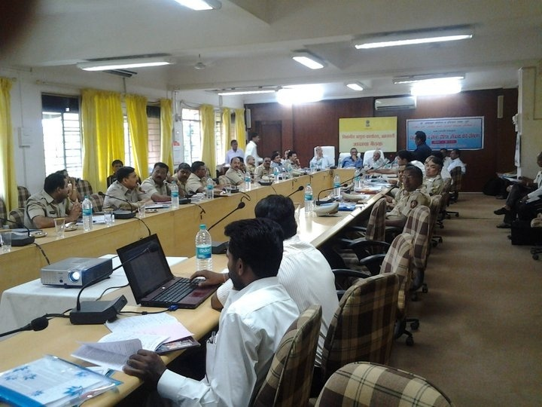
After the High Court ordered the Government of Maharashtra to enforce the SCs & STs (PoA) Act & Rules, as a response to our PIL, the Government institute named Dr. Ambedkar Research & Training Institute, Pune, started training the district level officials authorized to implement the Act in the respective Districts. They have invited SWADHIKAR-NDMJ as the technical resource persons for these trainings. On 1st & 2nd June, they organized division-wise trainings for the District Magistrates, the Superintendent of Polices (SPs) and the Deputy Superintendents of Police. The training programs were led by Mr. P. S. Wankhede (Director – Dr. Ambedkar Research & Training Institute, Pune) and the members of the State SC/ST Commission, Mr. M. R. Patil and Mr. C. L. Thool.

On 1 June, the officials of the 6 districts of Nagpur Division were trained at the Divisional Commissioners’ Office, covering the DMs, SPs and DSPs of Wardha, Nagpur, Chandrapur, Bhandara, Gadchirolia and Gondia; and on 2 June, the officials of the 5 districts of Amravati Division were trained, covering the DMs, SPs and DSPs of Buldhana, Akola, Washim,Amravati and Yavatmal.

National Workshop for Handbook on SCs & STs (PoA) Act & Rules, Feb 20-22, ISI, New Delhi
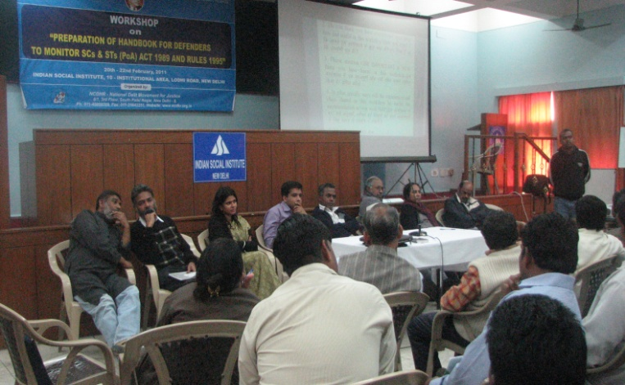
Activists and Dalit Human Rights Defenders from across the country, possessing experience ranging from 5-20 years in monitoring violations of Dalits Human Rights attended the workshop.

More than 50 Human Rights Defenders shared their experiences; successes and failures encountered in the process of using new strategies and suggested possible steps to defend Dalits human rights. Discussions revolved around the processes involved in defending Dalits human rights, viz. the offences, complaints, registration of FIR, the investigation process and filing of charge-sheet, trial proceedings, relief, rehabilitation, compensation, district and state level authorities, district-level and state-level Vigilance and Monitoring Committee and the statutory bodies.

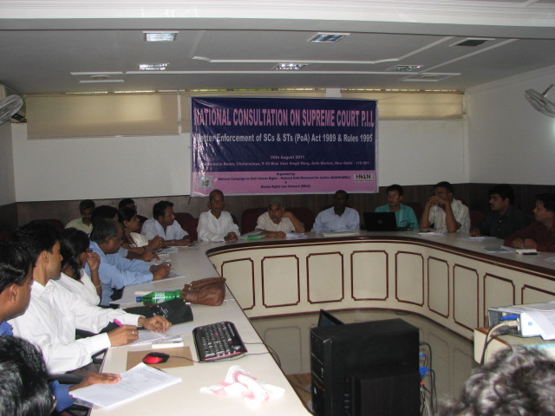
National Consultation on Supreme Court PIL August 20, 2011
In the year 2006 ,National Campaign on Dalit Human Rights, Centre for Dalit Rights and Sakshi Human Rights Watch, filed a Public Interest Litigation (C.W.P. No. 140 of 2006), on the non implementation of the SCs and STs [PoA] Act 1989 and Rules 1995. The Supreme Court had directed Union of India, all State Governments and UTs, Ministry of Social Justice and Empowerment, Ministry of Law and Justice, Ministry of Home of Affairs, NHRC and SC Commission to file their responses. So far, Union of India, Ministry of Social Justice and Empowerment and Ministry of Home affairs filed a joint affidavit and 16 States and UTs have filed their counter affidavits. On the other side, many of the major states with huge number of atrocity cases have not filed their affidavits till date. In this context, to activate the ongoing PIL, one-day National level Consultation was organised in Delhi on August 20, to evolve a strategy to follow-up the PIL both at the State and National levels. Around 40 CSOs from 13 States (Orissa, Bihar, Tamil Nadu, Maharashtra, Uttar Pradesh, Jharkhand, Rajasthan, Himachal Pradesh, Karnataka, Haryana, Madhya Pradesh, Andhra Pradesh and Tripura) discussed the status of implementation of the Act and the possible way forward.

Based on the discussions on non implementation of various mandatory provisions of the Act and Rules, all the states agreed to provide the data available with them on the various gaps, which will be accumulated. Later, based on the data available, an additional affidavit will be filed in the Supreme Court.

An interface with MLAs and Parliamentarian of the Maharashtra on the proper and effective implementation of the SC/ST (Prevention of Atrocities) Act and Rules, Maharashtra, July 29, 2011
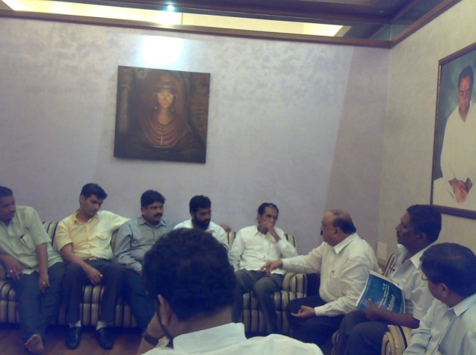
A meeting of Dalit MPs, MLAs and MLCs, was organised through the Secretary, SC & ST Forum of MPs and MLA, which was attended by a total of 12 MLAs, MLCs/MPs. In the meeting, various issues related to the Dalits, such as, diversion of funds from special component plan, dropout of Dalit students from the primary education schools, land and water related issues, housing, and discrimination in scholarships were discussed. In their agenda, the forum also included the issue of non implementation of the PoA Act and Rules. NDMJ apprised the members of the forum on the non implementation of various monitoring and accountability mechanisms under the Act and Rules. We also gave the questionnaires, report card and proposed amendments on the PoA Act to all the MLAs and MPs. The members agreed to raise the issue of the non implementation in the ensuing sessions. Some MLAs also showed their interest to meet us later on with the draft status on some of the issues

Building and Strengthening Civil Society Networks: National Consultation with Organizations

We organized one National level consultation “National Consultation of Tribal Peoples’ Movements & Organizations on SCs & STs (PoA) Act & TSP” at Deputy Speaker Hall, Constitution Club, New Delhi on 26th & 27th Mar’11. 149 participants (60 NGOs & activist, 30 Media persons, Union Minister for Social Justice & Empowerment, 1 Member of Parliament, 2 IAS (Rtd.) Officials)

State Consultations with CSOs working on different issues of human rights

We organized two state level consultations with CSOs & activists, working on different issues of human rights in Maharashtra on15th & 16th Feb’11 & Madhya Pradesh on 10th Oct,10 during this reporting period. A total of 155 participants (55 NGOs & 100 activists) covering 40 District participated. We jointly organized the consultation with university of Mumbai, ADR & YUVA where MP, MLA, SC&ST Commission Member, Nodal Officer, Sr. Reporters, Vice Chancellor of University, Director, HOD of Law Dept. their Academic Staff, Representative of Political party, Asst. Director of SW etc. attended the consultation. It had great impression in the civil society about the workings of NDMJ.

Training of Dalit Human Rights Defenders

We have organized one training programme for Dalit human rights defenders for preparation of handbook on PoA Act at Indian Social Institute, Lodi Road, in Delhi on 20^{th &} 23rd Feb’11 A total of 50 Activists and Dalit Human Rights Defenders across the Country having 5 - 20 years of experience in monitoring of Dalit Human Rights violation in their respective states participated.
Monitoring & Sensitizing of Enforcement Agencies and Authorities: Filing RTI Applications in 14 states
We filed and following up applications under Right to Information (RTI) as routine activity as per the monitoring calendar for better enforcement of the provisions of the SCs & STs (PoA) Act, 1989 & Rules 1995.
We are regularly filing RTI applications every 20th, 30th & 31st of the month as per the provision of the Act, to activate the authorities under the Act and also to get information on the status of the implementation of the Act.
Filed RTI applications filed in 26 States & 3 UTs: 743 RTIs (598 Dist. & 299 State level) covering 201 Districts of 29 States & Union Territories. Response received 657 (358 Distt. & 299 State level)

Survivors Meetings with Enforcement Authorities

We organized 5 meetings in Orissa:24 & 25 Jan,11(6 Victims & survivors of 4 cases).
Bihar: 15th Feb’11 (47 victims & survivors of 25 cases). Uttar Pradesh: 16 &17 Feb, 11
(13 victims & survivors of 9 cases), Madhya Pradesh: 28-29 March, 11 (10 Victims & survivors of 5 cases), Maharashtra 31st March, 11, (1 victims & survivors of 1 case) with enforcement authorities along with 77 survivors / witnesses of 44 atrocity cases during this reporting period. Initially the survivors were given orientation on presentation of their cases to authorities.

Monitoring & Documentation of DHR Violations
We have undertaken 35 State level fact finding missions

Regular meetings with the parliamentarians and MLAs, Enforcement & Statutory Authorities
We organized several meetings on the better enforcement of the SCs & STs (Prevention of Atrocities) Act, 1989 in 9 States - Delhi, Uttar Pradesh, Haryana, Karnataka, Bihar, Orissa, Himachal Pradesh, Maharashtra & Madhya Pradesh meetings with enforcement authorities, under the PoA Act in this reporting period.

Meeting with Chairperson of Parliamentary Committee on Welfare of SC & ST

On 1st March, 2011, we met with the Sh. Gobinda Chandra Naskar, chairperson of the Parliamentary Committee on Welfare of SCs & STs. After thanking him for his intervention towards strengthening and review of the SCs & STs (PoA) Act & Rules, we discussed the current stand of the Committee vis-à-vis the review of the SCs & STs (PoA) Act & Rules. We offered him our full support on bringing together the Dalit Movements and Organizations during their review of the implementation of the Act in various States. He also suggested us to directly present some concrete instances showing the gaps or status of the implementation of the SCs & STs (PoA) Act & Rules.

Advocacy with National Commission for Scheduled Castes

We met with the Chairperson of the National Commission for Scheduled Castes, Dr. P.L. Punia as well as the Joint Secretary of the Commission, Shri T. Theethan on 10th March 2011 at their office. We had a thorough discussion on the amendment process initiated by the Ministry of Social Justice & Empowerment and also the possible role of the Commission towards the strengthening of the Act. With the Joint Secretary we had a round of discussion on the strategies for strengthening of the SCs & STs (PoA) Act & Rules. Later we also provided enough copies of the Proposed Amendment to be presented and discussed by the Members of the Commission.

Advocacy with Ministry of Social Justice & Empowerment

The Ministry of Social Justice & Empowerment, New Delhi sent a copy of Concept note on amendments to SC & ST (PoA) Act to all the State Governments, asking their suggestions/comments/feedback in bringing amendment to the Act. The Minister himself visited some of the states like Tamilnadu, Himachal Pradesh, Haryana, Rajasthan, Maharashtra & other states to inspect the situation & establish Exclusive Special Court for the trial of atrocity cases on daily basis.

Advocacy with Ministry of Social Justice & Empowerment on the Mirchpur case of Haryana

11.02.2011, Dr Prasad, Mr. Paul Divakar, Nandgopal, Shabnam Hashmi and Rahul Singh as a delegation met Union Minister, Mr. Mukul Wasnik, and Minister for Social Justice and Empowerment and discussed about the current factual problems of the victims and witnesses of Mirchpur Carnage. Some of the issues discussed were on the calling of several Khap Panchayats and agitations and violent activities as result of which 100 witnesses / victims were forced to flee from their houses, who are supposed to give their evidence before the court during trial, protection home for the victims and witnesses, appointment of Special Public Prosecutor. The Union Minister immediately after the deliberations called the Joint Secretary and apprised him of the factual situation and immediately and on priority basis takes up appropriate measures on the protection of victims and witnesses and the appointment of Spl P.P.

State consultations with MLAs, MLCs & civil society organizations

We organized 3 State level consultations - One under the banner of National Coalition for Strengthening SCs & STs (Prevention of Atrocities) Act (NCSPA) in Orissa on 20th Jan’11 & second under the banner of All India Dalit Mahila Adhikar Manch (AIDMAM) & Dalit Arthik Adhikar Andolon (DA3) in Bihar on 29th March’11 & third in Rajasthan on 31st March, 11 with MLAs, Bureaucrats and CSOs covering 249 participants – 140 CSOs & activists, 7 members from Commissions including Chairpersons & Vice-Chairpersons, 12 MLAs, 1 MP, 2 State Minister, 1 former Union Minister, 4 IPS officers, 1 former DGP, 3 Academicians, 15 Advocates, 8 Dalit women sarpanches, 55 persons from both electronic & print media. The programme aimed at sensitizing the members on the status of implementation of the SCs& STs (PoA) Act. The team met with numerous MLAs, MLCs and other respected authority figures and also prepared a ‘Fact Sheet’ of the status of enforcement of the Act for respective states for the last 21 years.

Volunteer orientation for monitoring political rights

We supported NDEW to organized 35 volunteers orientation programme in Uttar Pradesh and Bihar to monitor election process. We monitored 65 constituencies of 20 Districts by 915 volunteers in Bihar & 321 polling booth under 41 blocks of 20 Districts by 321 volunteers in Uttar Pradesh.

Interventions with UN Special Mechanisms:

- Organized meeting with UN Independent Expert on Minority issues at Jaipur, Rajasthan22nd Dec, 10.
Prof. Gay. J. McDougall, the UN Independent Expert on Minority issues visited India from 17 – 22 December, 2010. During her visit National Campaign on Dalit Human Rights (SWADHIKAR) in collaboration with Centre for Dalit Rights (CDR) organized a consultation at Jaipur (Rajasthan) on 22nd December 2010 with Dalit victims/survivors including women Sarpanches, Community and NGO leaders.
This consultation gave an ample opportunity to the independent Expert to interact with 48 Dalit survivors, activists including 17 women who participated very actively and shared their own individual cases in which they undergone serious challenges from the dominant caste, police officials, administration etc.
- Organized meeting with UN Special Rapporteurs & Experts, 15th Jan,11 UN Conference Hall, New Delhi
NDMJ anchored the deposition of Dalit Human Rights Defenders before Ms. Margret Sekaggya, UN Special Rapporteur on Human Rights Defender, on January15, 2011, at the UN Conference Hall. She has been mandated to report the various violations of rights of Human Rights Defenders in various Countries. The participants deposed numerous testimonies about human rights defenders who had been killed, tortured, threatened, arbitrarily arrested, detained, forcibly displaced an more because of their work, while working for justice to Dalits. Ms. Sekaggya pointed out that Dalit human rights defenders faced particular risks and ostracism and that the central and state government as well as the National Human Rights Commission must do more to protect the rights of human rights defenders. Ms. Margret in her press note immediately after the visit raised her concern on non-implementation of SC & ST (PoA) Act.

INTERNATIONAL ADVOCACY

Swadhikar through its various movements within SWADHIKAR have taken these aspects over several years and now propose to link the national mechanisms with the UN Human Rights mechanisms that have been ratified by India in order to create greater spaces for effective implementation of policies which empower Dalits and other marginalised communities.

Objectives:
- To advocate for the UN Human Rights mechanisms to address the issue of Caste and discrimination on work and descent.
- To strengthen the representation of the Dalit and Marginalised communities in utilizing UN Human Rights instruments and mandates primarily within India and across South Asia wherever possible.
- To strengthen the advocacy for effective of implementation of policies concerning Dalits and the marginalised in country.

Interventions:

- Advocate in the UN Human Rights Mechanisms
  - Participate in the UN Human Rights Council to
    - Monitor the sessions with respect to the issues of Discrimination based on Work and descent (DWD).
    - Intervene in the sessions to raise the issues of DWD and related aspects and concerns.
    - Strengthen collective efforts to support issues of similar concerns in other countries.
  - Intervene as per the mandate of Special Rapporteurs on the following themes
    - Education
    - Human Rights Defenders
    - Independence of Judges and Lawyers
    - Independent Expert on Minority Issues
    - Racism
    - Economic Social Cultural Rights

- Strengthen the representation of the Dalit and Marginalised communities
  - Trainings and workshops for Dalit and Marginalised Communities in participation in the UN mechanisms.
  - Facilitation of participation in the UN HR mechanisms for Dalits and marginalised communities.

- To strengthen the advocacy for effective of implementation of policies at National level.
  - Participate in the coalition of Dalit and other marginalised groups in focusing on national policies
  - Interact with national government in its position on HR concerns at the UN.
  - Interact with Dalit groups and leaders from Asian countries to strengthen the collective efforts at both national and UN levels.
Activities for the year 2010-2011

- Consultation with Ms. Margret Sekaggya, UN Special Rapporteur on Human Rights Defender on Dalit Women, Dalit Community Leaders & HR Defenders.

Ms. Margret Sekaggya the UN Special Rapporteur, stated her mandate and her objective of the visit. She also stated that, since she is not assessing the Government of India and that she has already seen the plight of Human Rights Defenders, she requested all the deponents to be brief and suggest concrete recommendation, which she can add in her report so that the same be commented by the Government of India be used back by the civil society for advocacy follow-up. She came out with a strong press release and promised to include the specific problems of HRD’s in India which will be published in March 2012

- Seminar on Minority issues and Social Exclusion in South Asia: Challenges and Responses by State & Civil Society, Positive Practices, Learning’s and Future Tasks. Ms. Gay McDougal, Independent Expert on Minority Issues participated in this seminar which was organised on 18 – 19 December 2010.

Background

In recent years there has been a growing awareness among the national, ethnic, religious and linguistic minority communities in different parts of the world of their identities, rights and entitlements. That this has been so in the complex and diverse regions of South, South East and East Asia is obvious. Increasing understanding of the importance of their traditional values, the perceived threats from the majority communities in their milieu, certain powerful globalising trends endangering their survival and cultures, and the percolation of democratic values and rights into their day-to-day life can be listed as some of the more prominent causal factors. Apart from the positive gains of such awareness, one is confronted also with a scene where the rights and entitlements of these communities are grossly violated.
It is in this context a seminar related to minority rights and issues were organized. The regional seminar offered a unique opportunity to address minority issues and social exclusion. The focus of the two days was on the identification of recommendations for concrete actions and change at the national level. .
Participants from South Asia included civil society activists working among minorities and socially excluded groups, community leaders, representatives of women’s rights organizations, human rights defenders and representatives of human rights organizations.

Gay shared that from her experiences it is clear that protection of minority rights is a critical factor in conflict prevention. There is no way that societies can accomplish a level of economic development without conflict prevention. These are global problems, and not just a problem in India or in this region of the world, and it is crucial to find a solution and in finding common causes with other communities in the world. She felt that there is an important need to come together and find ways to see how those linkages can be made. As long as minorities remain within the horizon of their communities they will not gain the required power to push boundaries in their favour. ‘We need some united way to move forward and look beyond these horizons and find linkages’ she emphasized.
Another discussion was to look at social exclusion while looking at current challenges. This discussion looked at different issues using the lens of gender, language, sub caste, religion, and ethnicity. Two days seminar looked and examined the issue of minority rights and various other intricacies related to the same subject like: Minority Rights and Social Exclusion- Experiences and Challenges, Positive Practices and Learning. There was also an action oriented plan regarding this.
Gay McDougall facilitated a short discussion on the various systems and mechanisms that can be used by civil society groups working on Minority Rights in the UN. Here she primarily discussed the various entry points that may be used for use of international mechanisms. These she identified as:
- Geneva Bodies
- Treaty Bodies
- Regional Mechanisms
- Domestic Mechanisms (available in terms of international mechanisms)

Graham Fox walked the group through the recommendations of the three forums on Minority Issues. Graham Fox is based in Geneva and is an international civil servant and with the broader mandate of converting information received and turning the same into action.
Delegates discussed this issue under various thematic headings
- Education
- Economic Life
- Political Participation
Women’s Informal Meeting with Gay McDougall
In continuation to the visit an informal discussion was organised by AIDMAM (All India Mahila Adhikar Manch) on issues pertaining to women. The objective of this discussion was to appraise her on the emerging contexts which have affected the rights of women; particularly those belonging to minority and excluded communities. This interaction with Prof. Gay brought together women academicians, activists and practitioners from various fields to participate and contribute to building her understanding on the dynamics & challenges faced by women in India. This was also an opportunity for all to meet, share and strengthen relations. The discussion focused on various issues faced by women in India.
There was also a discussion on the situation of DWD in the UN with Prof. Gay McDougall on 20th December 2010.

- Geneva Conference on Decade of Dalit Rights- 24- 28 June 2011
The push given by the Bellagio Consultation on the UN World Conference Against Racism in January 2000 for inclusion of caste discrimination in the WCAR Agenda became a public demand in WCAR in 2001 when a large number of delegation from India and other countries affected by discrimination based on work and descent clamoured for the inclusion of this issue in the inter-governmental official text of WCAR. Though the non-inclusion in the governmental text seemed a setback, the recognition of caste discrimination as a heinous crime by the global civil society’s NGO Forum at WCAR was a big gain. Moreover, in the past one decade since WCAR, the enormous efforts undertaken by various civil society actors from and outside the caste affected countries to engage the governments of the concerned affected countries, various UN bodies, the EU as well as certain governments in Europe, and the subsequent significant outcomes gained as a result of such efforts necessitated a pause for assessment of the past and designing the future.
To make a historical note here, the seed for having such review and future planning was sown on the occasion of the Regional Seminar on “Minority Issues and Social Exclusion in South Asia: Challenges and Responses by State and Civil Society, Positive Practices, Learning’s and Future” held in New Delhi on 18-19 December 2010. The planning set in motion from then onwards moved into the direction of holding five events:

OUR TEAM

Abirami Jotheeswaran
National Dalit movement for Justice
Program coordinator

Anju Singh
All India Dalit Mahila Adhikar Manch
Program Assistant

Ambalika Roy
All India Dalit Mahila Adhikar Manch
Program Coordinator

Amit Nayak
National Dalit movement for Justice
Research Associate

Ashim Boral
National Dalit movement for Justice
Programme Coordinator

Ashutosh Vishal
Dalit Arthik Adhikar Andolan
National coordinator
Beena J Pallical
Swadhikar
Manager-Resource Mobilzation

Bhaskar
All India Dalit Mahila Adhikar Manch
Office Assistant

Binish Nafees
All India Dalit Mahila Adhikar Manch
Program coordinator
Deepika Shokeen
All India Dalit Mahila Adhikar Manch
Program Assistant

Eramma
National Dalit movement for Justice
Office Assistant

Jesintha Mary
National Dalit movement for Justice
Associate Coordinator- Research & Advocacy

Hannah Johns
International Advocacy
Research Associate

Keshav Jailiya
National Dalit movement for Justice
State coordinator

Lee Macqueen Paul
National Dalit Watch
Research & Advocacy Officer

Madhu Parsoya
Dalit Arthik Adhikar Andolan
Finance Executive

Manoranjan Choudhary
National Dalit movement for Justice
Finance Executive

Mohit Jain
Swadhikar
Admin Associate

Munnu Swami
Swadhikar
Office Assistant

Namrata Daneil
All India Dalit Mahila Adhikar Manch
Program Coordinator

Ragini Sharma
Dalit Arthik Adhikar Andolan
Research Coordinator

Pradeep Pandit
All India Dalit Mahila Adhikar Manch
Finance Executive

Rahul Singh
National Dalit movement for Justice
Coordinator- Research & Advocacy

Sindhu. K
Swadhikar
Secretary- Administration

